PROJECT DESIGN PHASE – 2

DATA FLOW DIAGRAM AND USER STORIES

|  |  |
| --- | --- |
| 28 | 05 OCTOBER 2022 |
| TEAM ID | PNT2022TMID27630 |
| PROJECT NAME | Virtual Eye - LifeGuard For Swimming  Pools  To Detect |
| MAXIMUM MARKS | 4 MARKS |

|  |  |  |  |  |  |
| --- | --- | --- | --- | --- | --- |
| **User Type** | **Functional Requireme**  **nt (Epic)** | **User**  **Story** **Numbe**  **r** | **User Story / Task** | **Acceptance**  **criteria** | **Priority** |
| Customer (Mobile user) | Installation | USN-1 | As a user, I can install the virtual eye - lifeguard drowning system | I can install | High |

DATA FLOW DIAGRAM :

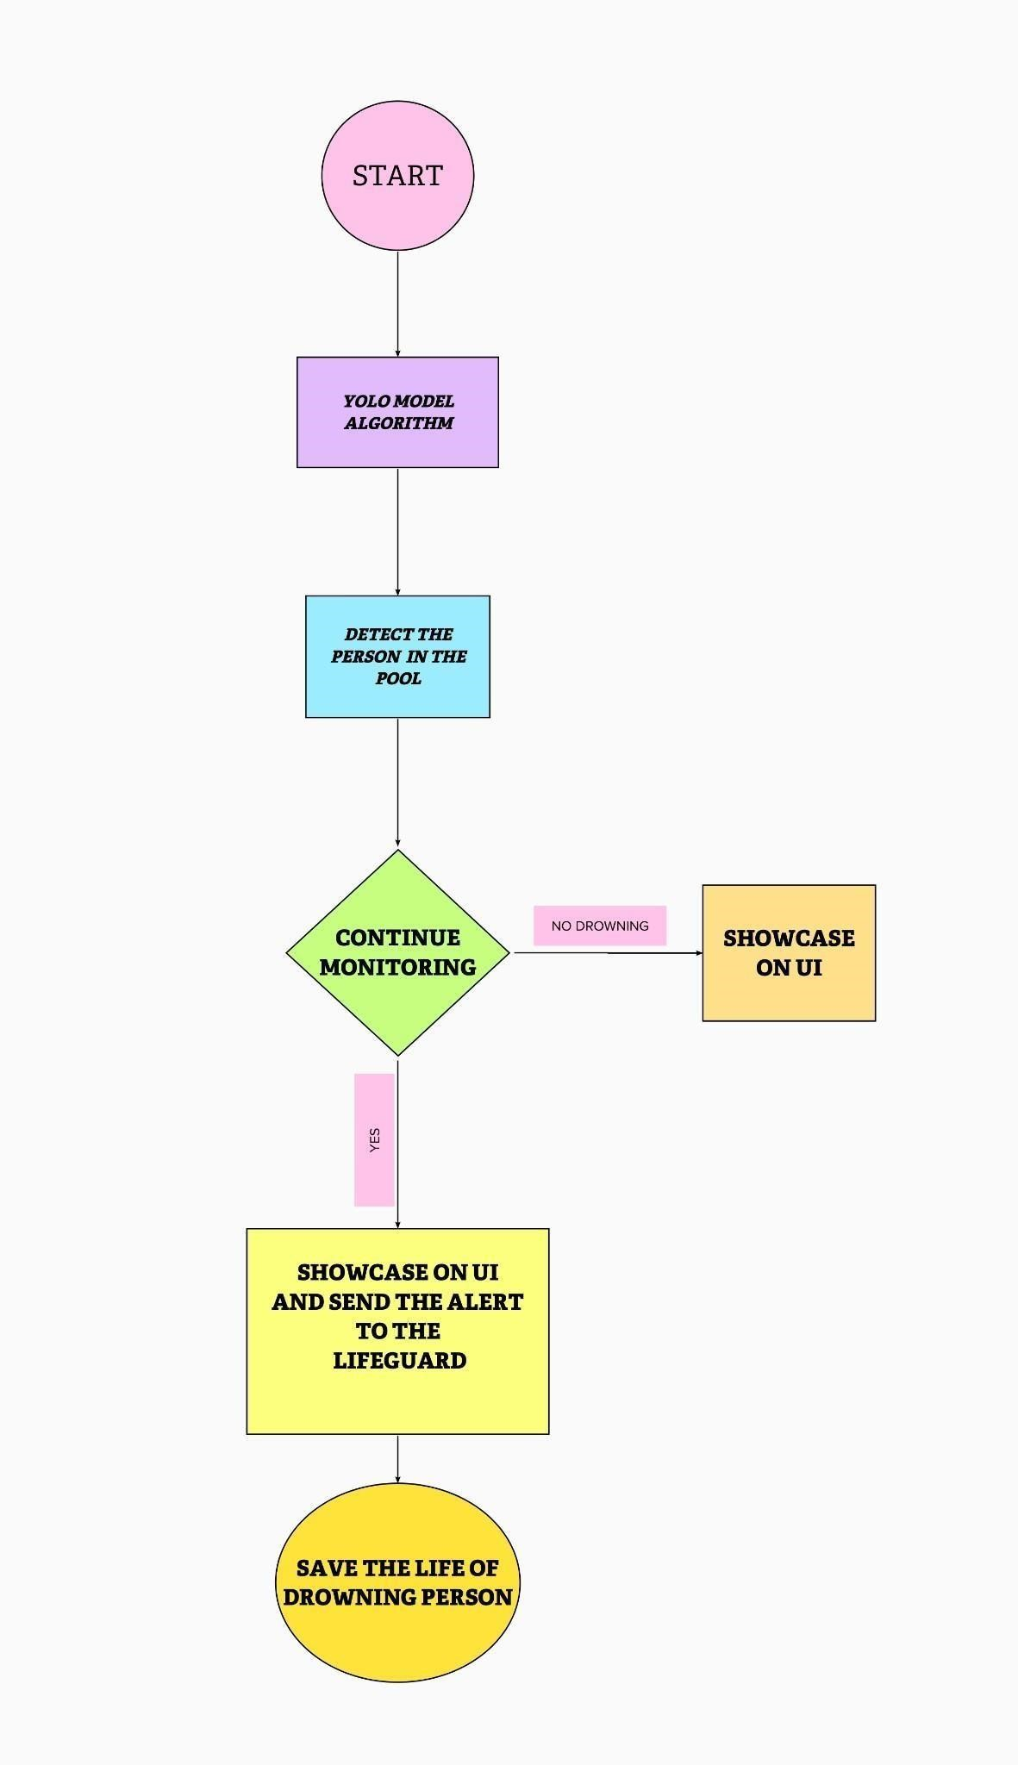

|  |  |  |  |  |  |
| --- | --- | --- | --- | --- | --- |
|  | Deduction | USN-2 | As a user, I will receive confirmation about the drowning detection | I can receive confirmation about detection | High |

USER STORIES :

|  |  |  |  |  |  |
| --- | --- | --- | --- | --- | --- |
|  | Support | USN-3 | As a user, I can get the support from the virtual eye system | I can get the support | High |
|  | Prior Alert | USN-4 | As a user, I can get the alert when the person is drowning | I can get the alert | High |
|  | Protection | USN-5 | As a user , I can save the person from drowning | I can save the person | High |
|  |  |  |  |  |  |
| Customer (Web user) |  |  |  |  |  |
| Customer  Care  Executive | Customer  care | USN-6 | As a user, I can contact customer care about the drowning system | I can get the service from  customer care | High |
| Administrat  or |  |  |  |  |  |